ECEN 100 – Project: Weather Station

Introduction
One of the most useful sensor that come in your kit is the DHT11. This sensor can measure humidity as well as temperature. In this project you will use the DHT11 to measure these two parameters as part of a weather station.

Hardware Needed
For this project you’ll need the DHT11. There is one in your kit.
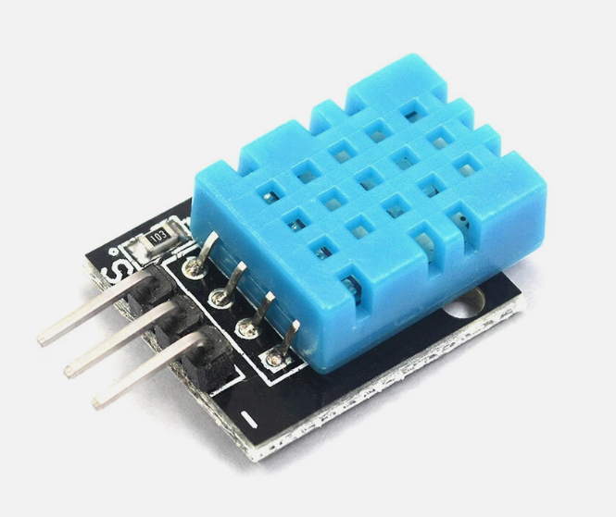
That’s it.

Connecting the DHT11 to Your Development Board
The DHT11 is very easy to connect. It requires a ground connection, a voltage connection (this can be either 3.3 or 5 Volts), and a signal connection. For this example you can connect the GND and 3.3 volt connections to the Power section of the pins on the development board, and the signal connection to pin 13.
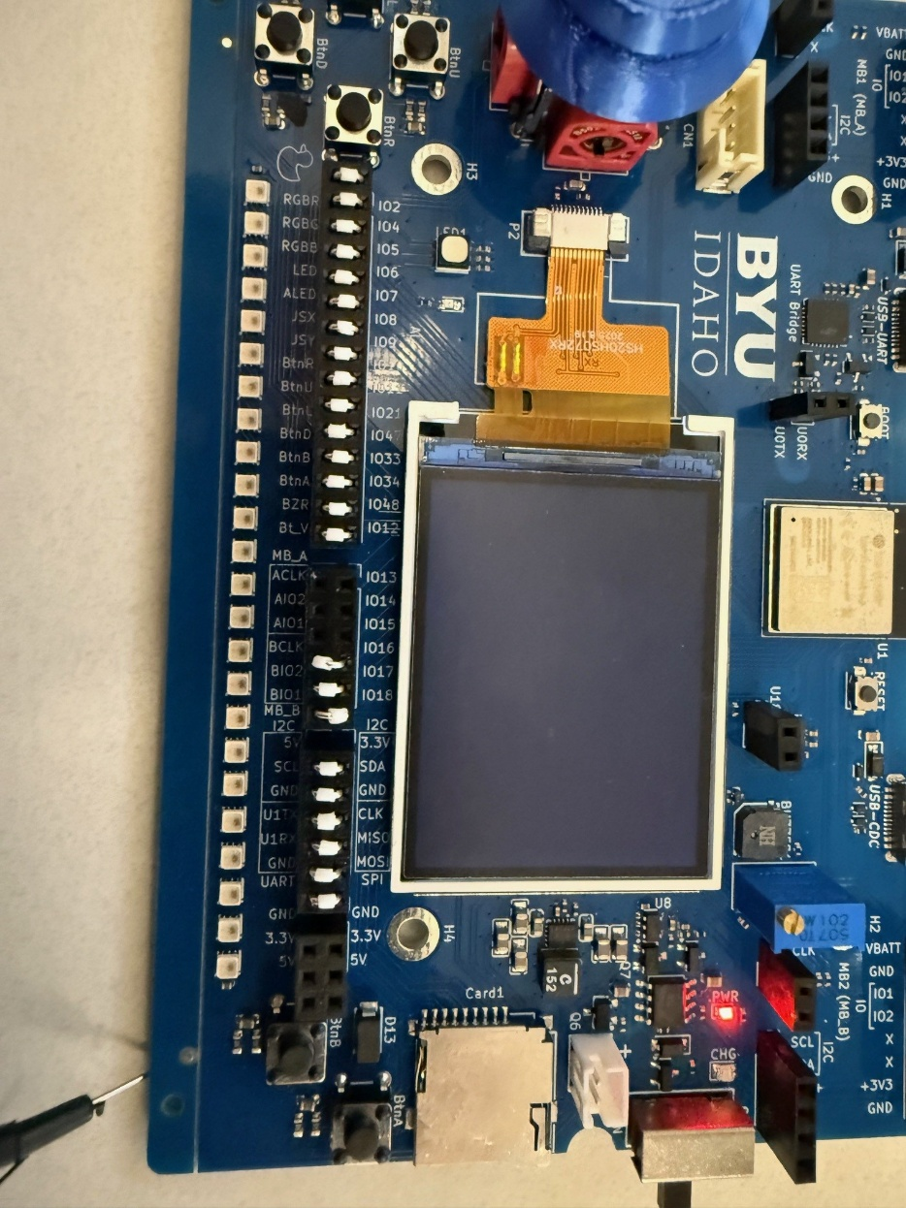

A Simple Arduino Sketch to access the Data
The following sketch shows how to access the data using the Serial Monitor.
#include "DHT.h"

// Define GPIO pin connected to the DHT sensor
#define DHTPIN 13
// Define sensor type
#define DHTTYPE DHT11

DHT dht(DHTPIN, DHTTYPE);

void setup() {
Serial.begin(115200);
Serial.println(F("DHT11 Test"));
dht.begin();
}

void loop() {
// Wait 2 seconds between measurements
delay(2000);

// Read humidity
float h = dht.readHumidity();
// Read temperature in Celsius
float t = dht.readTemperature();

// Check if readings failed
if (isnan(h) || isnan(t)) {
Serial.println(F("Failed to read from DHT sensor!"));
return;
}

Serial.print(F("Humidity: "));
Serial.print(h);
Serial.print(F("% Temperature: "));
Serial.print(t);
Serial.println(F("°C"));
}

Copy this code into a sketch and then save and upload it. If you get an error that the DHT.h library is not installed you’ll need to install the library. Choose this library by first selecting the library icon on the far left, then installing this library.
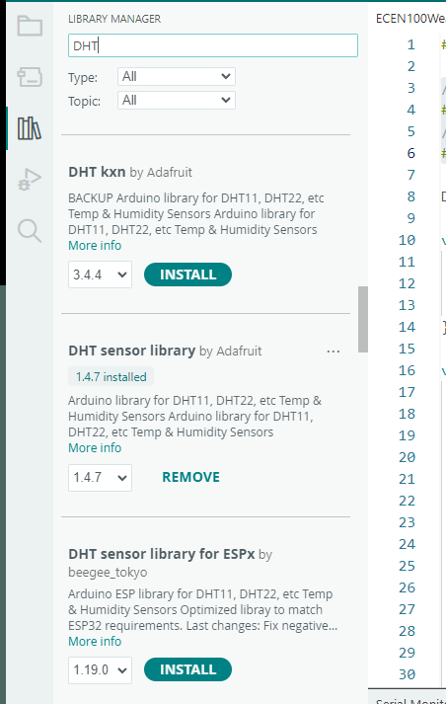
When you run the sketch you can open the Serial Monitor and you should see something like this:
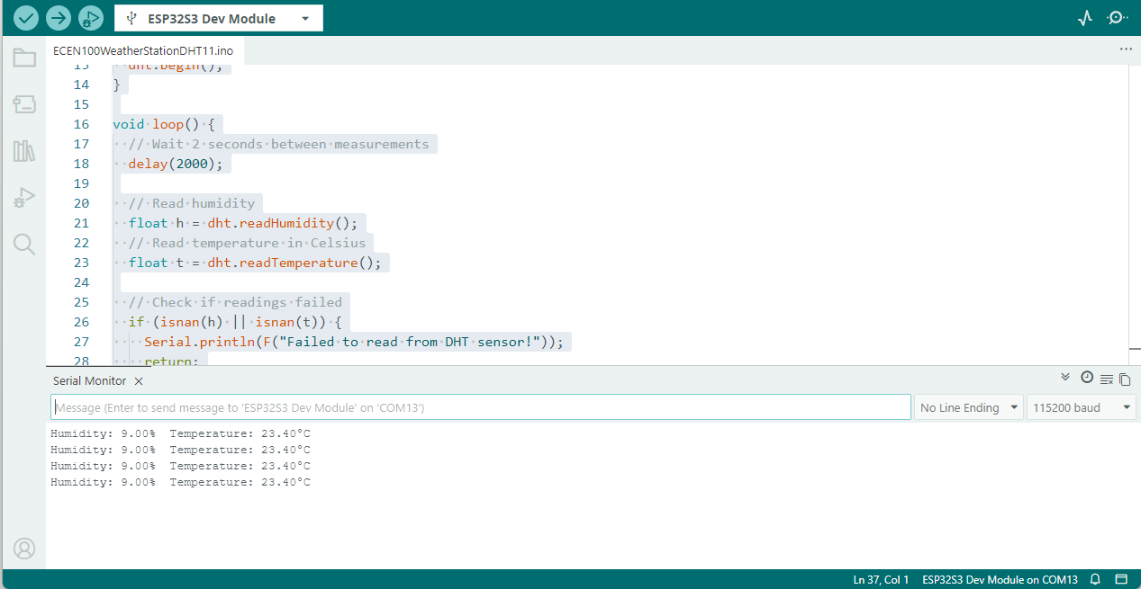

If you don’t see the data then check the Baud Rate.

Adding Displaying the Graphics to the Screen of the Development Board
The
#include <Adafruit_GFX.h>
#include <Adafruit_ST7789.h>
#include <SPI.h>

// Pin definitions for ESP32-S3 (Adjust if using different pins)
#define TFT_CS 0
#define TFT_RST 1
#define TFT_DC 45
#define TFT_MOSI 3
#define TFT_SCLK 46
#define TFT_MISO 10

Adafruit_ST7789 tft = Adafruit_ST7789(TFT_CS, TFT_DC, TFT_RST);

void setup() {
// put your setup code here, to run once:

SPI.begin(TFT_SCLK, TFT_MISO, TFT_MOSI);
// Initialize ST7789 240x320
tft.init(240, 320);
Serial.begin(115200);
tft.init(240, 320);
tft.setRotation(1); // Adjust rotation as needed
tft.fillScreen(ST77XX_BLACK);
tft.setCursor(60, 100);
tft.setTextColor(ST77XX_GREEN);
tft.setTextSize(3);
tft.println("Setup");
delay(1000);
tft.fillScreen(ST77XX_BLACK);

}

void loop() {
tft.setCursor(60, 100);
tft.setTextColor(ST77XX_GREEN);
tft.setTextSize(3);
tft.println("Loop");
delay(1000);
tft.fillScreen(ST77XX_BLACK);

}

You can upload and run this code and you’ll see the Setup text on the display for 1 second, then the Loop text.
You’ll need to integrate this code with the capability of the DHT11 to make temperature measurements. The code would look something like this:
#include <Adafruit_GFX.h>
#include <Adafruit_ST7789.h>
#include <SPI.h>
#include "DHT.h"

// Pin definitions for ESP32-S3 (Adjust if using different pins)
#define TFT_CS 0
#define TFT_RST 1
#define TFT_DC 45
#define TFT_MOSI 3
#define TFT_SCLK 46
#define TFT_MISO 10

// Define GPIO pin connected to the DHT sensor
#define DHTPIN 13
// Define sensor type
#define DHTTYPE DHT11

Adafruit_ST7789 tft = Adafruit_ST7789(TFT_CS, TFT_DC, TFT_RST);
DHT dht(DHTPIN, DHTTYPE);

void setup() {
// put your setup code here, to run once:

SPI.begin(TFT_SCLK, TFT_MISO, TFT_MOSI);
// Initialize ST7789 240x320
dht.begin();
tft.init(240, 320);
Serial.begin(115200);
tft.init(240, 320);
tft.setRotation(1); // Adjust rotation as needed
tft.fillScreen(ST77XX_BLACK);
tft.setCursor(60, 100);
tft.setTextColor(ST77XX_GREEN);
tft.setTextSize(3);
tft.println("Setup");
delay(1000);
tft.fillScreen(ST77XX_BLACK);

}

void loop() {
tft.fillScreen(ST77XX_BLACK);

// Read temperature in Celsius
float t = dht.readTemperature();

tft.setCursor(60, 100);
tft.setTextColor(ST77XX_GREEN);
tft.setTextSize(3);
tft.println("Temperature");
tft.setCursor(60, 140);
if (isnan(t)) {
tft.println(F("Read Failed"));
return;
}
else {
tft.println(t);
}

delay(1000);

}

When you upload the code you should see the temperature displayed.

Next Steps
You can now add the Humidity to the display, and perhaps make it more interesting by using meters or graphs.

Ideas to Take the Project Further
There are several excellent ways to extend the project.
- One would be to use the ESP32 as a hot spot and share the data over the internet as a webpage.

